Installation guide - https://docs.cloudstack.apache.org/en/4.20.1.0/installguide/index.html

Architecture:
Node | Role | Services
1 | Management + KVM Host | CloudStack Mgmt, MySQL, KVM
2 | KVM Host | KVM
3 | KVM Host | KVM

NIC 1: Guest + Public Traffic (ens3f0np0)
Used for:
VM guest network traffic
Public IP access (if VMs need internet)
Can be on a separate VLAN or routed network

Reserved pool in same network for guest vms: 172.24.137.1-50

NIC 2: Management + Storage Traffic (ens3f1np1)
Used for:
CloudStack management communication
NFS or iSCSI storage access
SSH access to hosts
Typically on a private VLAN or subnet

Reserved pool in same network for management/storage services - 172.19.117.114-123 ; 172.19.117.140-149

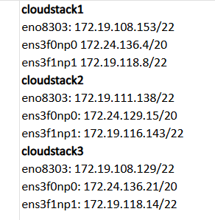

When using two NICs per server in Apache CloudStack, they should be on different subnets or VLANs if you want to separate traffic types effectively. Trunking is not necessary.
For Basic Networking (Flat Network), IP pool must match the NIC 1 ’s subnet. IP pool must be routable from your lab.
Static IP need to be reserved for each NIC. Communication between NIC1 and NIC2 on the same server is not necessary as they will be logically and physically isolated. NIC2 should be able to communicate with other NIC2s (management/storage traffic between hosts). NIC1 with other NIC1s (VM traffic across hosts and to external networks).

Step 0: Server configurations
On each host, Install rocky 9.2
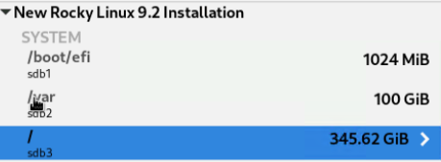
All NIC IPs might not be connectable. Interface with the lowest metric in ip route table will only be connectable as it is chosen for replies, breaking connections from other interfaces. To make all interface connectable, use policy-based routing.
Example configuration:
[root@cloudstack1 ~]# ip route
default via 172.24.128.1 dev ens3f0np0 proto dhcp src 172.24.136.4 metric 102
default via 172.19.116.1 dev ens3f1np1 proto dhcp src 172.19.118.8 metric 101
default via 172.19.108.1 dev eno8303 proto dhcp src 172.19.108.153 metric 100
172.19.108.0/22 dev eno8303 proto kernel scope link src 172.19.111.139 metric 100
172.19.116.0/22 dev ens3f1np1 proto kernel scope link src 172.19.118.8 metric 101
172.24.128.0/20 dev ens3f0np0 proto kernel scope link src 172.24.136.4 metric 100
Steps:
echo "102 ens3f0np0" >> /etc/iproute2/rt_tables
echo "101 ens3f1np1" >> /etc/iproute2/rt_tables
echo "100 eno8303" >> /etc/iproute2/rt_tables
ip rule add from 172.24.136.4/32 table ens3f0np0
ip rule add from 172.19.118.8/32 table ens3f1np1
ip rule add from 172.19.108.153/32 table eno8303
ip route add default via 172.24.128.1 dev ens3f0np0 table ens3f0np0
ip route add default via 172.19.116.1 dev ens3f1np1 table ens3f1np1
ip route add default via 172.19.108.1 dev eno8303 table eno8303
Persist across reboots
#create script
vi /usr/local/bin/policy-routing.sh
#add below content – modify as per respective interface IP
#!/bin/bash

# Add routing rules only if they don't exist
ip rule show | grep -q "from 172.24.136.4/32" || ip rule add from 172.24.136.4/32 table ens3f0np0
ip rule show | grep -q "from 172.19.118.8/32" || ip rule add from 172.19.118.8/32 table ens3f1np1
ip rule show | grep -q "from 172.19.108.153/32" || ip rule add from 172.19.108.153/32 table eno8303

# Add default routes only if they don't exist
ip route show table ens3f0np0 | grep -q "default via 172.24.128.1" || ip route add default via 172.24.128.1 dev ens3f0np0 table ens3f0np0
ip route show table ens3f1np1 | grep -q "default via 172.19.116.1" || ip route add default via 172.19.116.1 dev ens3f1np1 table ens3f1np1
ip route show table eno8303 | grep -q "default via 172.19.108.1" || ip route add default via 172.19.108.1 dev eno8303 table eno8303
sudo chmod +x /usr/local/bin/policy-routing.sh
#create service
sudo vi /etc/systemd/system/policy-routing.service
#add below content
[Unit]
Description=Apply policy-based routing rules
After=network-online.target
Wants=network-online.target

[Service]
Type=oneshot
ExecStart=/usr/local/bin/policy-routing.sh
RemainAfterExit=yes

[Install]
WantedBy=multi-user.target
#start service
sudo systemctl daemon-reexec
sudo systemctl daemon-reload
sudo systemctl enable policy-routing.service
sudo systemctl start policy-routing.service

Make IPs static on each server:
#For each interface
vi /etc/NetworkManager/system-connections/eno8303.nmconnection
vi /etc/NetworkManager/system-connections/ens3f0np0.nmconnection
vi /etc/NetworkManager/system-connections/ens3f1np1.nmconnection
#Add below under [ipv4] after replacing with respective interface’s inet IP and gateway IP from ifconfig
method=manual
address1=172.19.118.8/22, 172.19.116.1
dns=<dns IPS>
dns-search=<dns Search suffixes>
ignore-auto-dns=true
route-metric=101 # or 100, 102, etc. based on your routing plan
chmod 600 /etc/NetworkManager/system-connections/*.nmconnection
# do these from server console as ssh connection may drop
nmcli connection reload
nmcli connection up eno8303
nmcli connection up ens3f0np0
nmcli connection up ens3f1np1
reboot

Step 1: Create network bridge (on each node for ens3f0np0)
CloudStack expects a bridge (e.g., cloudbr1) mapped to the physical NIC that handles guest/public traffic (here, ens3f0np0). VMs attached to this bridge will get IPs from your specified pool and be reachable externally.
Edit /etc/NetworkManager/system-connections/ens3f0np0.nmconnection:
- Remove or comment out the [ipv4] section.
- Set
[ipv4]
method=disabled
nmcli connection add type bridge ifname cloudbr0 con-name cloudbr0 autoconnect yes
nmcli connection add type bridge-slave ifname ens3f0np0 con-name ens3f0np0-br master cloudbr0 autoconnect yes
Edit /etc/NetworkManager/system-connections/cloudbr0.nmconnection and set:
[ipv4]
method=manual
address1=172.24.136.4/20,172.24.128.1
dns=<dns IPS>
dns-search=<dns Search suffixes>
ignore-auto-dns=true
route-metric=102

Update /usr/local/bin/policy-routing.sh:
ip rule show | grep -q "from 172.24.136.4/32" || ip rule add from 172.24.136.4/32 table cloudbr0
ip route show table cloudbr0 | grep -q "default via 172.24.128.1" || ip route add default via 172.24.128.1 dev cloudbr0 table cloudbr0
update /etc/iproute2/rt_tables:
102 cloudbr0

nmcli connection reload
nmcli connection up cloudbr0
nmcli connection up ens3f0np0-br
reboot
When adding the KVM host in CloudStack later, specify cloudbr0 as the guest/public network bridge. Set your guest network IP range (172.24.137.1-50) in CloudStack’s network offering or zone configuration.

Step 2: Pre-requisites for cloudstack (on each node)
sudo dnf update -y
sudo dnf install epel-release -y
sudo dnf config-manager --set-enabled crb
sudo dnf install chrony -y
sudo systemctl enable --now chronyd
sudo setenforce 0
sudo sed -i 's/^SELINUX=enforcing/SELINUX=permissive/' /etc/selinux/config
sudo systemctl stop firewalld
sudo systemctl disable firewalld
sudo modprobe ipmi_devintf
sudo modprobe ipmi_si
sudo modprobe ipmi_msghandler
echo -e "ipmi_devintf\nipmi_si\nipmi_msghandler" | sudo tee /etc/modules-load.d/ipmi.conf

Step 3: Install cloudstack
configure repo (All nodes)
sudo vi /etc/yum.repos.d/cloudstack.repo
[cloudstack-4.20]
name=cloudstack
baseurl=http://packages.shapeblue.com/cloudstack/upstream/el9/4.20
enabled=1
gpgcheck=1
gpgkey=http://packages.shapeblue.com/release.asc

sudo rpm --import http://packages.shapeblue.com/release.asc
Install CloudStack Management Server (Node 1 only)
sudo dnf install cloudstack-management -y
sudo dnf install cloudstack-usage -y

Install CloudStack Agent (All Nodes)
sudo dnf install cloudstack-agent
Install KVM and Libvirt and give cloud user permissions (All Nodes)
sudo dnf install -y qemu-kvm libvirt libvirt-daemon-kvm bridge-utils
sudo systemctl enable --now libvirtd
sudo usermod -aG libvirt cloud
sudo visudo -> add this line at end
cloud ALL=(ALL) NOPASSWD:ALL
Install MySQL/MariaDB (Node 1 only) - Doc shows mysql in steps but we have mariadb here as Rocky Linux (and most RHEL-based distributions) ship MariaDB as the default MySQL implementation. MariaDB is a drop-in replacement for MySQL and is fully compatible with CloudStack.
sudo dnf install -y mariadb-server
sudo systemctl enable --now mariadb
Run interactive script : sudo mysql_secure_installation
- Set root password – password
- Remove anonymous users - yes
- Disallow remote root login - yes
- Remove test database - yes
- Reload privilege tables - yes
mysql -u root -p
CREATE DATABASE cloud DEFAULT CHARACTER SET utf8mb4;
CREATE USER 'cloud'@'localhost' IDENTIFIED BY 'password';
GRANT ALL PRIVILEGES ON cloud.* TO 'cloud'@'localhost';
FLUSH PRIVILEGES;
EXIT;

Edit /etc/my.cnf and add:
[mysqld]
innodb_rollback_on_timeout=1
innodb_lock_wait_timeout=600
max_connections=350
log-bin=mysql-bin
binlog-format='ROW'
sudo systemctl restart mariadb
Configure CloudStack Database (Node 1)
cloudstack-setup-databases cloud:password@localhost --deploy-as=root

Configure CloudStack Management Server (Node 1)
cloudstack-setup-management
Configure CloudStack Agent (All Nodes)
Edit /etc/cloudstack/agent/agent.properties to set the correct host IP and management server IP.
sudo systemctl enable --now cloudstack-agent

Step 4: Configure zone: core->advanced (sec group disabled)
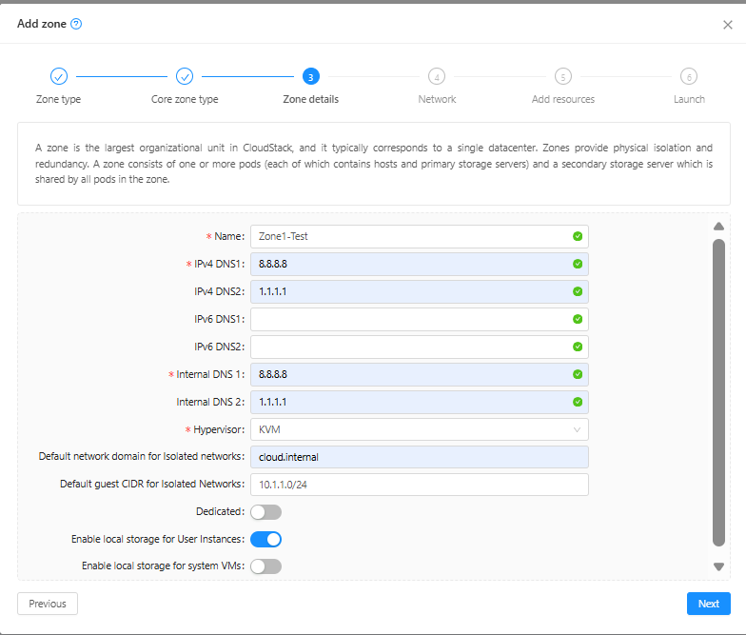
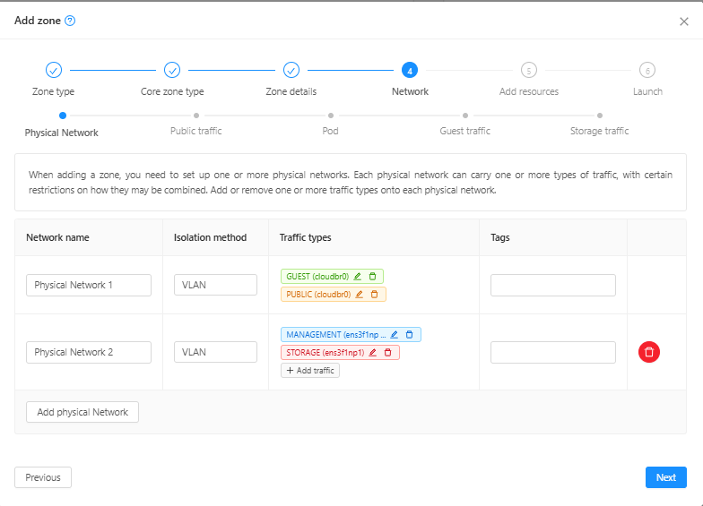
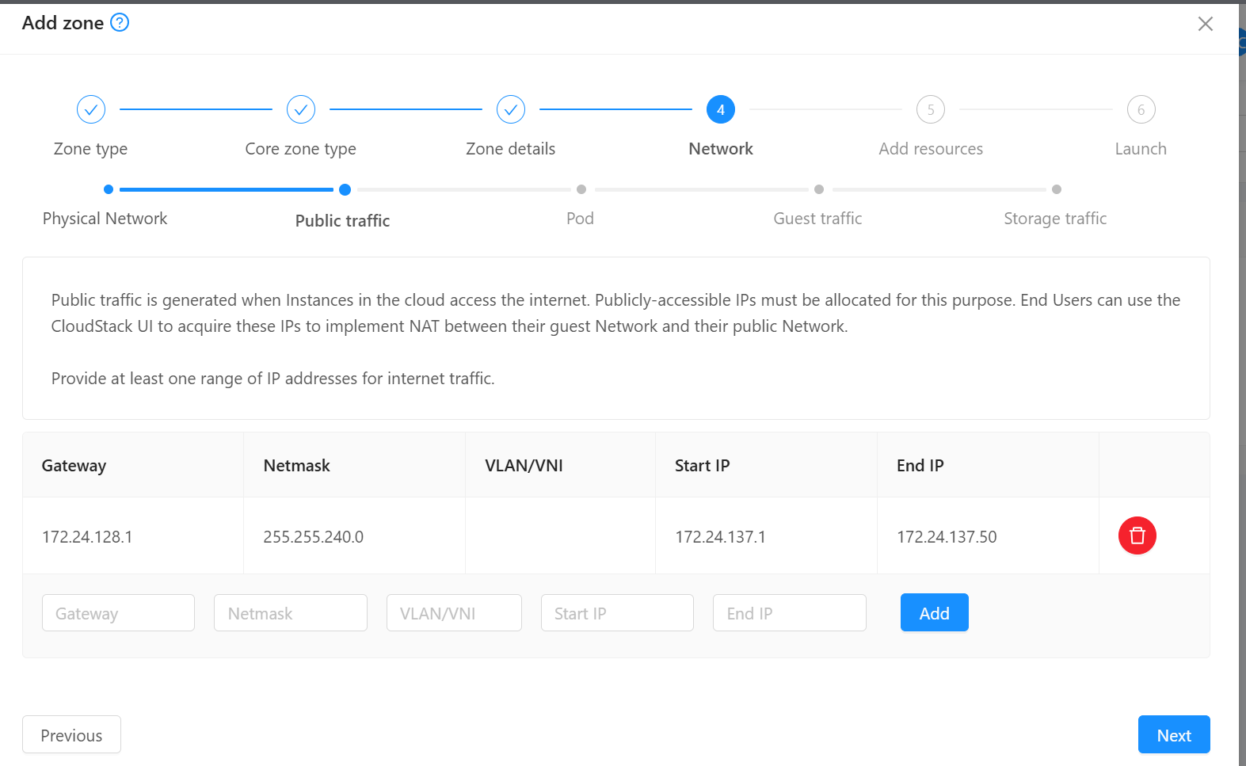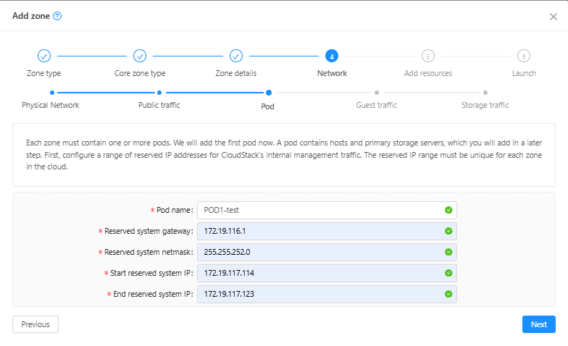
dummy range
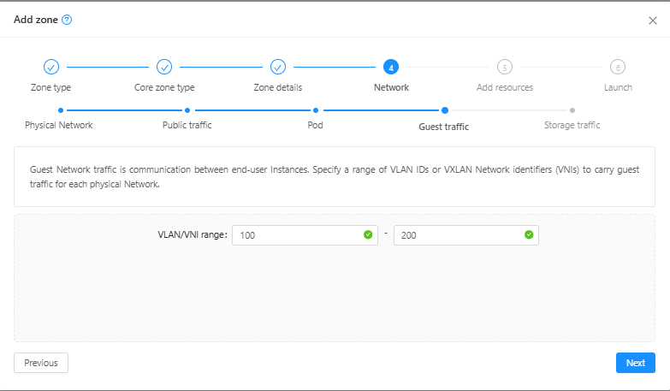
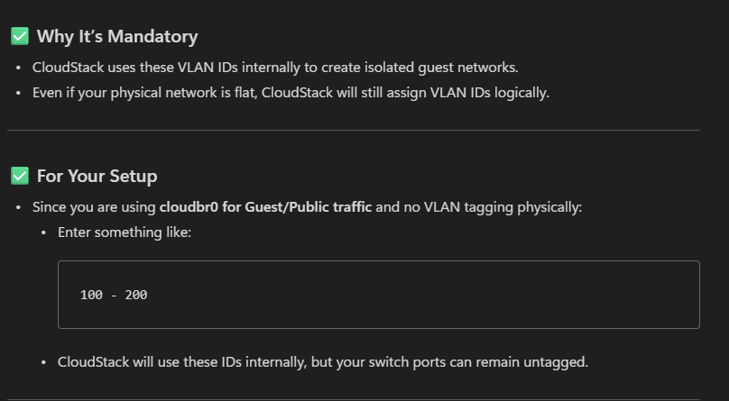
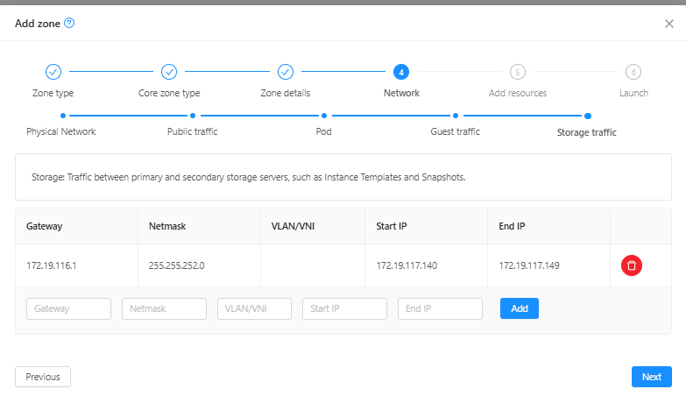

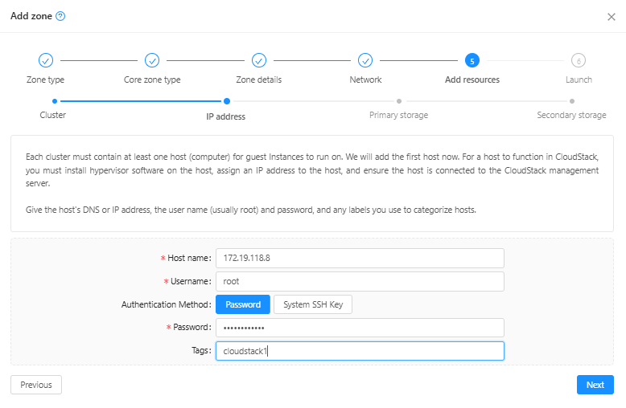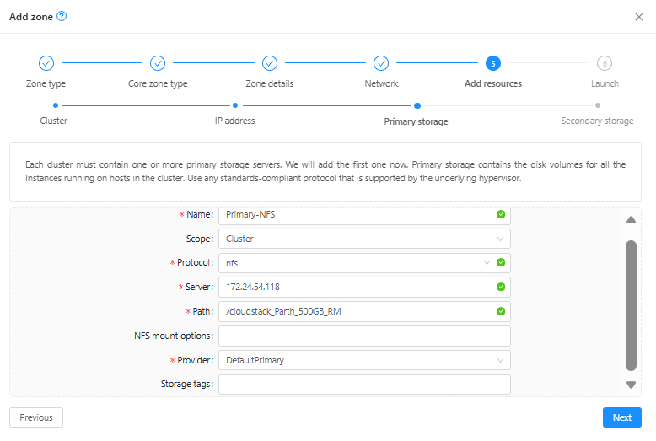
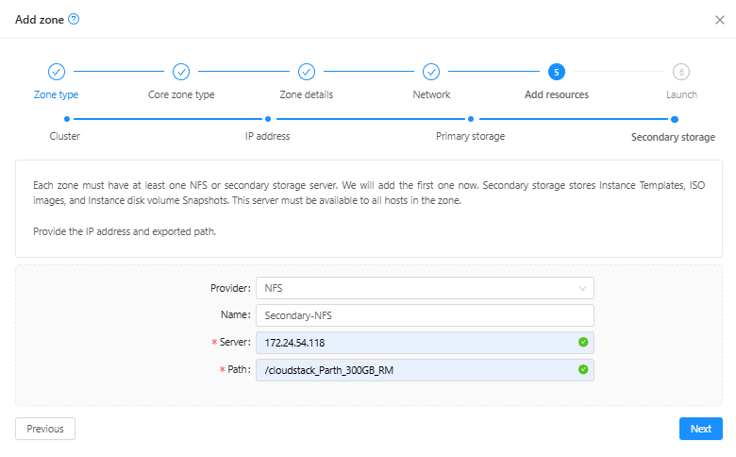
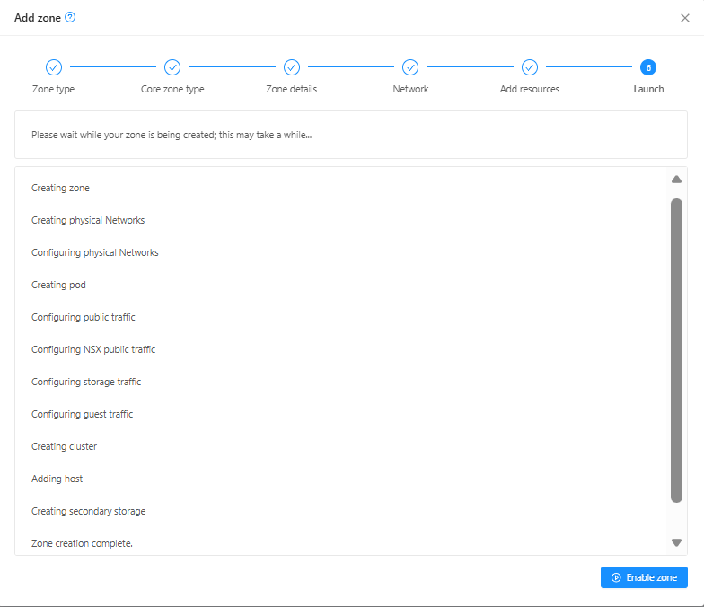

Add the other 2 hosts.
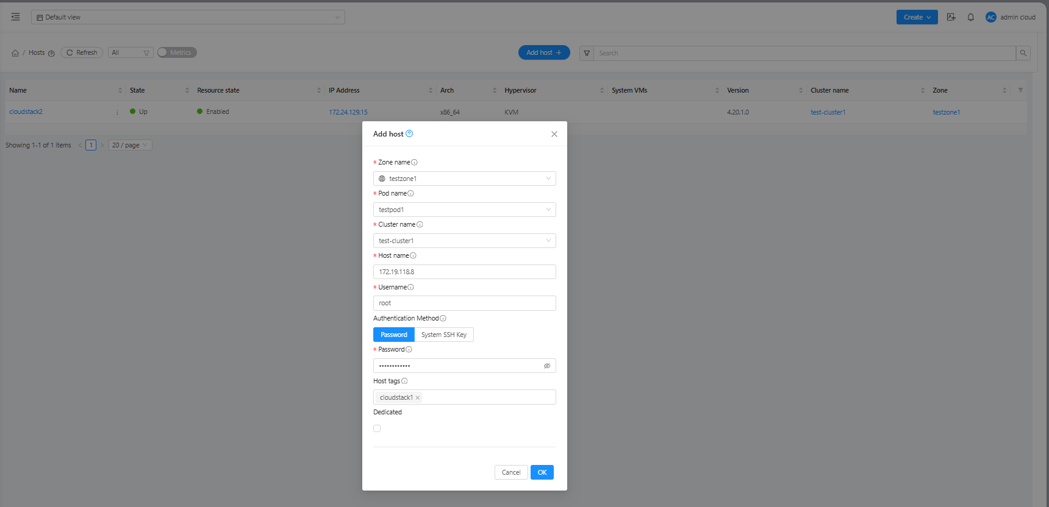
Add primary storage – iscsi (ext4 – shared mountpoint single writer)
On each CloudStack host:
yum install iscsi-initiator-utils device-mapper-multipath –y
# Discover targets
iscsiadm --mode discovery --type sendtargets --portal 172.24.34.32
iscsiadm --mode discovery --type sendtargets --portal 172.24.34.33
iscsiadm --mode node --login
# Enable multipath
mpathconf --enable --with_multipathd y
systemctl start multipathd
multipath –ll

# On one host
mkfs.ext4 /dev/mapper/mpatha
#on all hosts
mkdir -p /mnt/primary
mount /dev/mapper/mpatha /mnt/primary
echo "/dev/mapper/mpatha /mnt/primary ext4 defaults,_netdev 0 0" >> /etc/fstab

